# ESDR2 Translation Context Legend

When translating, you may need to know the context of a “string” (aka translation). This document aims to help the translator better understand the context of a translation on the new ESDR2 website.

Typically, the “ID” key of a translatable string will be in the column “A” of the CSV (Excel) document. The context hint will generally be contained within the “ID” after an underscore (“_”). For example, the key “about_copy1” tells the translator that this is a *copy* context. In other words, this text will be used in a paragraph context.

## _heading

“_heading” will be used for any of the many headings on the site. Generally, in English, these will be capitalized.

Example: “district_directory_heading” = “District Directory” (English)

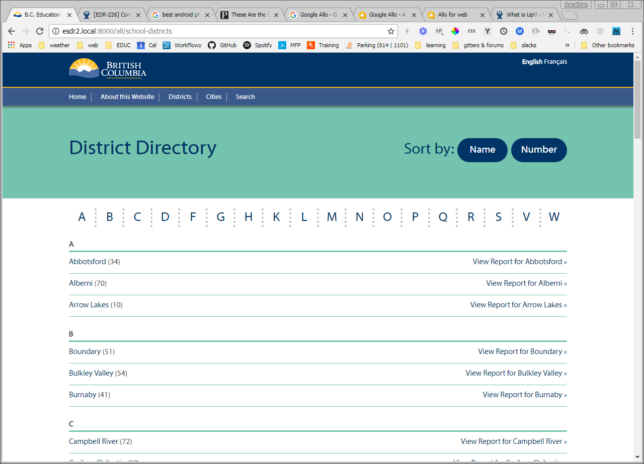

## _tagline

“_tagline” is used as a major sub-heading or explanatory text. The text may be more than one sentence and should have proper punctuation.

Example: “tagline” = “This online tool summarizes information collected each year by the B.C. Ministry of Education for all school districts across the province. It complements new planning efforts that are underway to enhance student learning in every school and school district in British Columbia.”

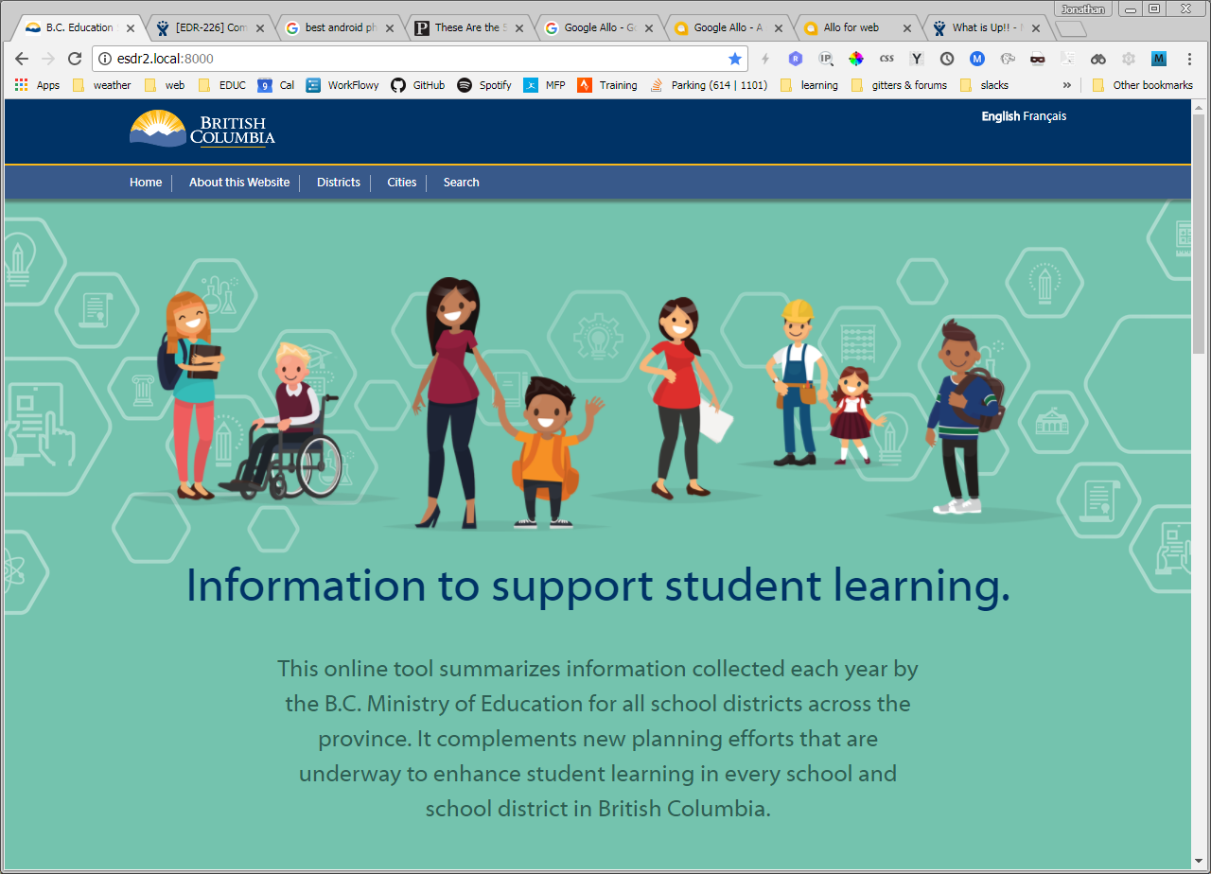

## _copy / _inline / _alt

“_copy” is used for paragraph text. The text may have more than one sentence. Sometime, “_copy” is broken up into more than one string. This allows for the insertion of a “_link” (see below).

Example1: “I am _copy1 and this is a” “_link1” “and I am _copy2.” As you can see, spacing and punctuation may be continued outside of a single string and continued in another after the insertion of a link.

Example2: “footer_google_copy” => “This website uses Google Analytics to track visitor traffic.”

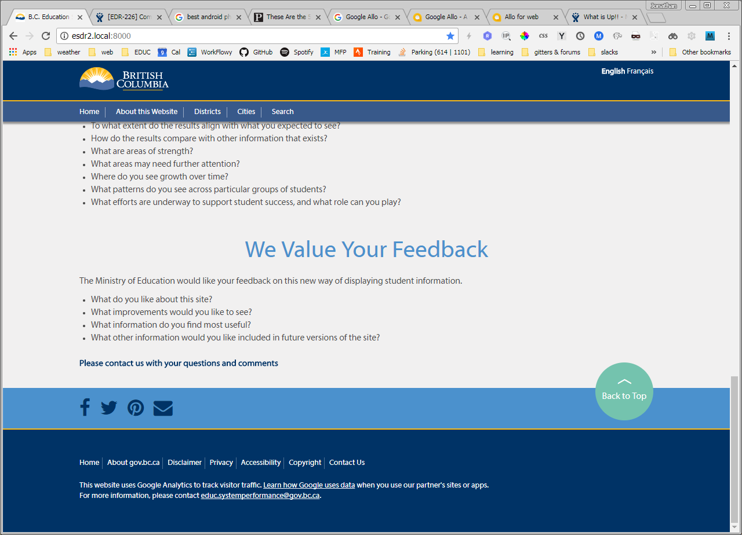

## _question

“_question” is used much like “_copy” however it is used in an unordered list of questions on the site. For the translator, “_question” can basically be treated like “_copy”.

## _link

“_link” is a call to action in a footer or header or an *inline* link inside of copy. Note, “_link” is not “_button” or “_label”. These are capitalized in English as they are proper labels. “_link” is used inside “_copy” to create HTML links.

## _button and _label

“_button” and “_label” are generally capitalized in English and they are labels on buttons or labels of meta information.

Example: “school_plural_label” => “Schools”, “school_singular_label” = “School”

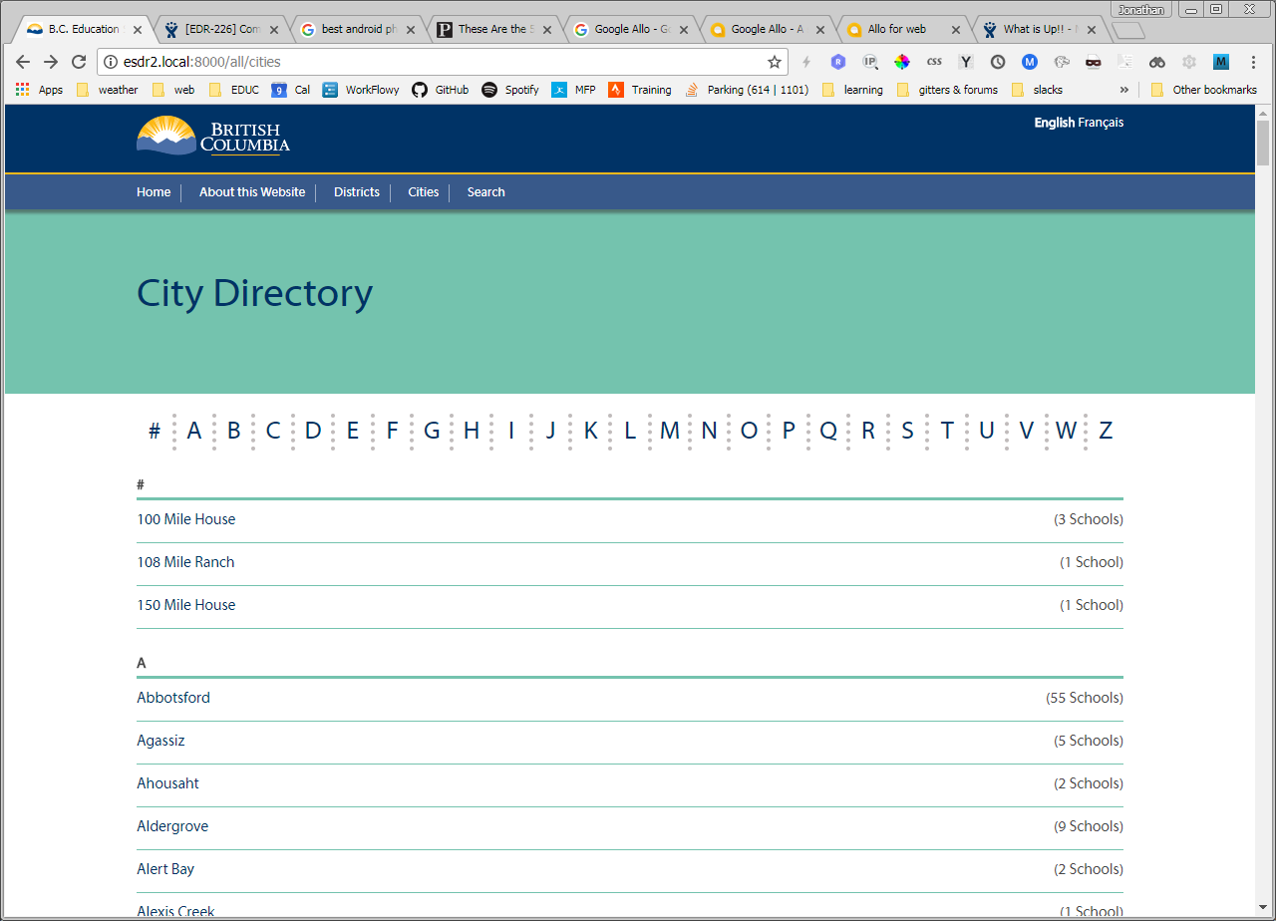

## _desc

“_desc” is not presented visually but is instead used in the HTML output to describe certain things on the page. In general, it can be treated as “_copy”.

## _trigger

“_trigger” is a label used on a call to action. It may appear as button label.

## _subject

“_subject” is used as an email subject line that would be sent to a user of the site.

## _error

“_error” is an error message. Generally, it will be the same as copy in terms of context but with a negative mood.

Example: “no_data_error1” = “There is no report data available for this school.”

## When an “ID” does not have a _context

When an “ID” does not have a context ending with an underscore + one of the above descriptions, it should probably be treated as “_copy”.